Assignment: Wired Remote Control
1) Construct ( or borrow) a 2-button wired remote control.

2) Program motors as follows:

if left button pushed, left motor goes backwards
if left button released, left motor goes forwards

if right button pushed, right motor goes backwards
if right button released, right motor goes forwards
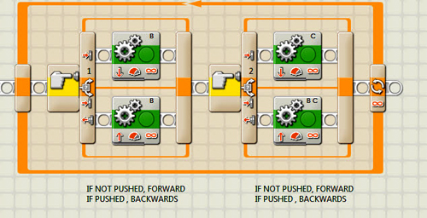

3) Extra Credit:
Add:
if object sensed < 12", sound "Danger"
if object > 12", no sound

Demonstrate and print out
Do you prefer autonomous or operator control of the robot?

