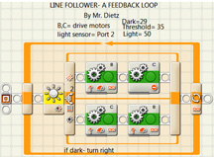


Team Members
James Madison
Martha Washington

For questions, contact:

January 15th, 2010

Advanced Lego Robotics

Weston Middle School

Weston, MA.

Program
The Destroyer

Team Members
James Madison
Martha Washington
Team Name
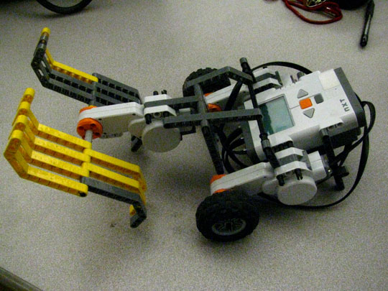
Special Thanks
I want to thank Jimmy Dean, who shared his leg design with us, and Davy Jones, who helped us with the programs.
We also found useful information on the website http://nxtprograms.com, as well as in the book NxT Creatures, by Fay Rhodes, and the videos at Youtube.

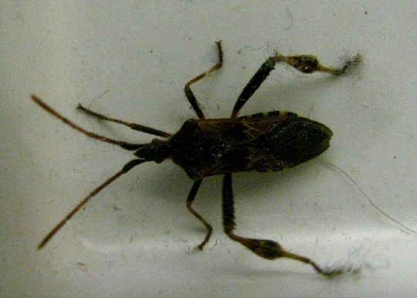

What we planned to build and why
James Madison wanted to build a bomb-defusing robot, but we couldn't figure out how to locate the bomb. So we decided to build the bug robot. At first we used wheels to move the bug, but then Martha came up with the leg mechanism which she found in the book by Faye Rhodes.
We had a lot of trouble getting it to walk smoothly- the feet kept slipping, so we made them larger and added sticky tape.

Main Inside Heading

Product Overview
The robot looks like a bug, with pincer jaws, 6 legs ( 2 are fake) and long antennae which act as sensors. The bug reacts when you touch the antennae or when it finds food( blue blocks).

Design Features
The bug crawls on its feet, which alternate. It has two antennae which are touch sensors.
When you hit "Run" it says on the screen what it reacts to ( touch and blue blocks).

Summarize the program: (algorithm steps)
1) Loop: go forward, turn left, turn right, stop for 2 sec, repeat
2) If the antennae are touched, it turns and runs away
3) If it sees food, it grabs it with its pincer jaws.

detail of pincer jaws
The inspiration for our project
Why you think this is the coolest device for 2010.

Because who wouldn't want a robot bug crawling under your bed?

