Grade 7 Robotics Final Project- The Robotic Amusement Park
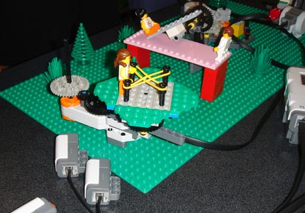
Design Challenge:
You are to design, build, and program a mechanical structure, ride, or machine that would be found in an amusement park.

The structure must:
- Move one or more mechanisms such as turntables, winches, merry-go rounds, etc.
- Have at least 3 steps to its operation. Steps may include responding to a standard Lego vehicle( supplied).
- Make sounds( verbal, music, beeps, etc) while movements are taking place
- Respond to stimuli such as light, touch, ultrasound, or microphone. 10 points for each stimulus utilized. (30 maximum).

Possibilities include:

- Pirates of the Caribbean
- Drawbridge that opens and closes when a ship comes along
- Cable Car/Trolley
- Bumper Cars
- Tilt-a-whirl
- Elevator/Tower of Terror
- Moving Mannequin
- Crane
- Pirate Ship Pendulum
- Rube Goldberg Apparatus
- Carnival Ride

See http://en.wikipedia.org/wiki/Amusement_ride for more ideas.

For mechanisms, ideas may be obtained at: http://www.flying-pig.co.uk/mechanisms/

See also Youtube videos at http://www.weston.org/schools/ms/technology/robotics/gallery.htm

Programming Hints: Basic behavior of ride or creature could be controlled by conditional behavior loops controlled by light sensors or timers, with sounds in parallel sequence bars. It is critical that you describe behavior first (algorithm) before writing code.
Program simple behaviors first, then gradually add complexity.

Scoring:
- Proposal: 10 points
- Programming: 30 points-includes algorithm and program
- 3 Journal Entries
- Project: 30 points, with bonus points for artistic merit
- 1 page/5 paragraph report
- 10 minute Group Presentation

