COMPLETE PALETTE- DATA HUBS
With the Complete Palette, we can use sensor values to control sounds and movement
Types of blocks:
- Common Palette Blocks
- Outputs (motors, lamps, sounds, etc)
- Inputs ( sensors)
- Flow ( loops, switches, etc. )
- Data ( arithmetic and variables)
- Advanced
Opening Data Hubs
Data Hub Challenge Part 1:
- Program a car whose speed is proportional to how loud you are yelling at it
- ( connect Sound Sensor output to Power input on Move Block)
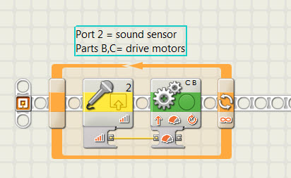

- Data Hub Challenge Part II: Program to control steering using a steering wheel( motor rotation sensor)
-100 = left
0= straight
+100= right
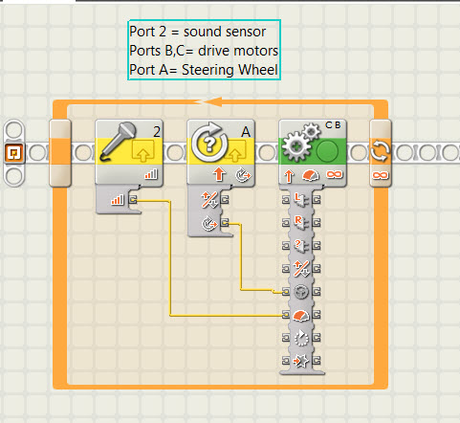

How do we make it more or less sensitive?
Hint: Use Arithmetic Blocks to multiply or divide number

- Data Hub Challenge Part III: Program to control forward/backward speed( power) using throttle( motor rotation sensor)
-100 = full power backwards
0= stopped
+100= full power forwards
Note: You need to use set and use the Direction Control +/-

