Challenge: Self-Parking Vehicle
When your Lego vehicle finds a parking space between two parked "vehicles", it must autonomously parallel-park itself into the space.
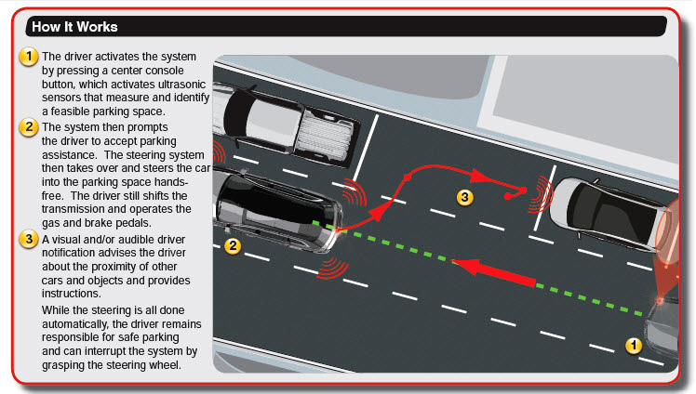

You must demonstrate a working vehicle that will park itself, and hand in a fully documented program.

Challenges:
- Program your vehicle to back into a space
- Program your vehicle not to hit the car in back
- Program your vehicle to exit a space
- Program your vehicle to detect a space
- Once a space is detected, program your vehicle to move to the correct position to back into the space
- Test entire program

