Sumo-Bot Challenge:
Build a robot which will push your opponent out of the ring( or otherwise destroy him).
- Your robot must stay inside the ring by itself, using its own sensors.
- Your robot should have a weapon using gears which is activated by the opposing robot.
- It should have multiple behaviors- i.e. search and destroy, play dead, spin around, etc.
To use the light sensor, you need to first determine a threshold level( trip point) midway between the dark level and light level, using the View function.
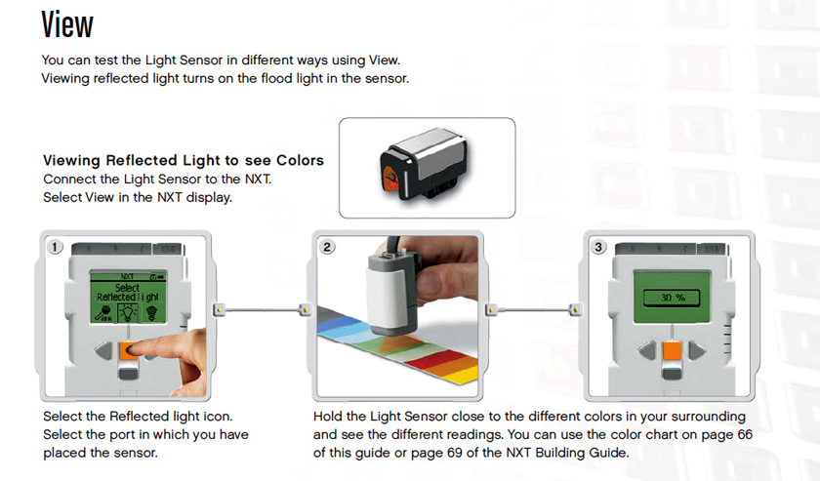
When you begin program:
- Write Title of Program
- Your names
- Ports
- Measure dark and light levels using View Function
- Range:
  - dark= 25-33 (example)
  - light= 48-53
  - Threshold should be halfway between dark and light
• Story
• then place Icons

Milestones(keep modifying program, saving new versions):
Milestone 1:
- Go forward indefinitely, wait for white(light >35?), then stop
Milestone 2:
- Go forward indefinitely, wait for white(light >35?),
- Back up 12"
- Turn robot around
- repeat (loop)
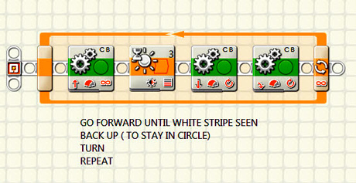
Milestone 3:
- Build a weapon using your 3rd motor- use gears to place the "business end" out where it can do some damage!
Milestone 4:
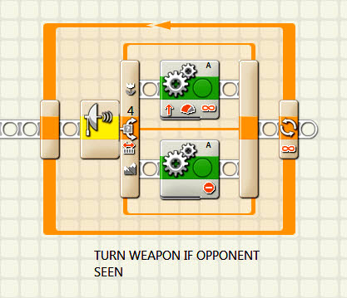
- Add parallel loops to your program to control weapon and make sounds, etc.
Part 5: The Switch
Weapon should only go when opponent close
- What are some ideas you have for attachments?
- How could you modify the program for a better attack strategy?

