Sample Challenges:
What are the problems that need to be solved for each?

Ant colony challenge: A worker ant goes out and looks for food( red bricks). When it finds it, it can communicate to another robot ant in the colony where it is, enabling the second ant to head directly to the food.
Robotic Band- 2 or more robot musicians combine to play music. Includes bells and other percussion. Each robot should play a passage, then signal to the other robot musician to come in at the correct time. Robots may use sound generator, but must physically move as well- banging drum, strum guitar, or signal to other musician.
Robot Guitar Tuner
Stereotaxic Surgery - Build a Robot simulator for stereotaxic brain surgery- Operator enters polar coordinates( Right ascension, declination) and depth of probe, and robot moves probe to the correct position.
Laparoscopic Robot- Robot has laparoscopic pincer tools, which can be operated very precisely using wired remote controls.
Bomb Disposal Robot: Robot locates "Bomb", picks it up, and carries it to a safe container and drops it in, after which there is an explosion.
Artbot: Robot paints pre-programmed pictures on paper using colored markers
Mapping Robot- Build an NxT system that tracks Bicycle Movement around school; person movement
Shooter Robot: Robot fires balls at target, controlled by accelerometer sensor.
Automatic Cup Holder- Build a robot that detects cups of different sizes, grabbing each securely.
Navigation Robot 1: Robot that can find its way through a series of (unknown) doors.
Navigation Robot 2: Robot can find its way from inside Room 142 to marked location on landing outside cafeteria. May use compass sensor.
Mars Surveyor- Mars Surveyor that autonomously maps 6' x 10' area of hallway using data collection.
Psychiatrist Robot: Robot that interacts with you socially, using text, smiles and frowns, speech, and handwaving.
NxT Boat- Build remote-controlled NxT boat

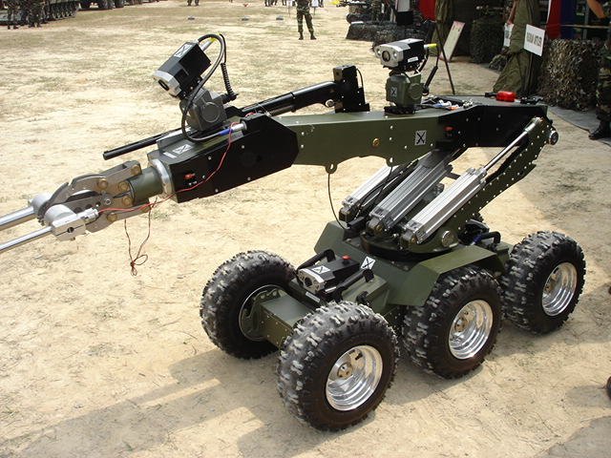
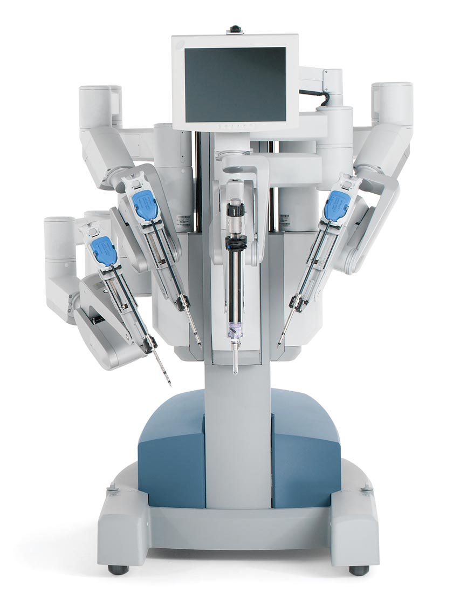
Bomb disposal robot

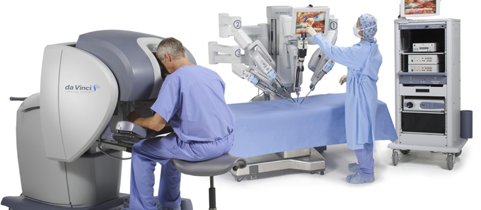
DaVinci Laparoscopic Surgery Robot
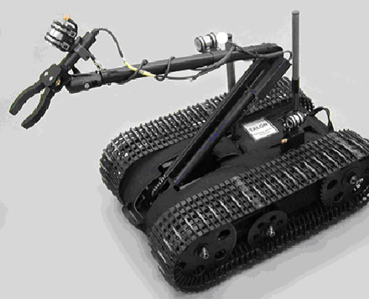
Talon Military Robot

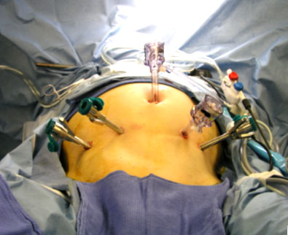
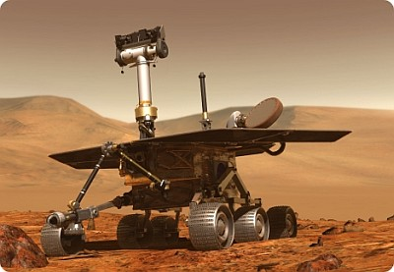

Brain Surgery Robot

Mars Spirit Robot

