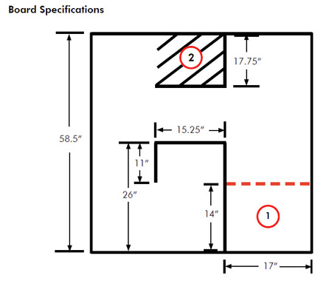
Challenge: Navigate a Maze
Your robot must navigate the maze from (1) to (2) without crossing any lines.
Steps:
1. Start a new program entitled "Maze"
2. In program workspace, using Comment tool,
type in a
- title
- you and your partner's names, and
- the ports, i.e., B&C= Drive Motors, Sound= 2, Light=3
Save to your folder on the server ( "Save As" Maze--Browse to your folder-OK -Save)
3. Describe the algorithm of how the robot will get from Point 1 to Point 2 (like in NASA Mars Rover Game), i.e.:
- Move forward 1 foot
- Turn left, etc
4. Put Move Blocks onto Sequence Beam
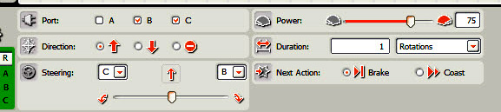
5. Configure Move Blocks- ports, direction, steering, power, duration until your robot can do the maze!
Maze- Advanced

- Add sound sensor- Robot starts when you say "go"--use "Wait for" sound- configure port-correct port, correct threshold
- Add light sensor- make turns when robot crosses small stripes

