Introduction to Programming- Part 1: Drive Test
Using Text Tool:
- Name Your Program
- List you and your partner's names
- Write Motor ports ( B, C)
- Describe what your robot will do
- "Save As" Get Going; browse to your student folder, "Save"
The Drive_Test program is a simple program that tests different kinds of driving, all using the MOVE block:
- Wait for sound (EC)
- Go straight Forward
- Go straight Backward
- Pivot turn (wheels turning opposite directions) to the Left
- Pivot turn to the right
- Stop
- Say "Good Job" (EC)
- Repeat (EC)
Write Program, Print out, Demonstrate
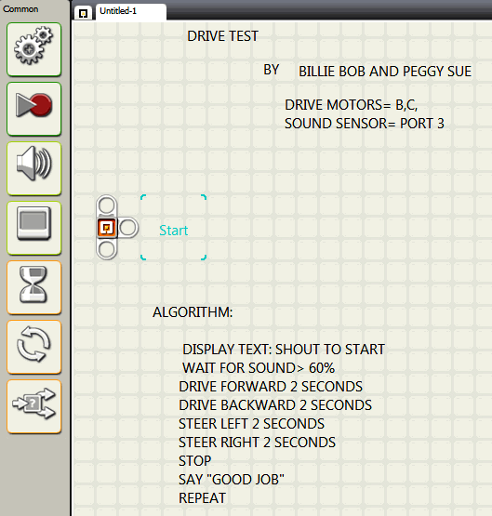

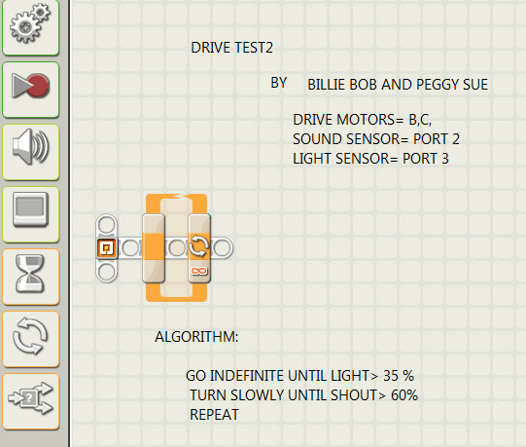

NOTE: USE VIEW BUTTON TO MEASURE THRESHOLDS

